’.https://docs.google.com/document/d/1DZrKXLtcMyIzHA9byu0u_WbSDqZWd3CrUZLzAYCmj28/edit?usp=sharin
https://create.kahoot.it/create#/new/quiz/done

Chapter 5: p 128-138
- Read p 128-129, then read your section of the Textbook
- Write 5-10 bullets for your section
- Do some research to find another unique or similar example (can be found in the textbook).
- Find 3 photos (or other media) to represent your section

 | Explanation | Unique/Similar Example
Introduction > | - support themselves through hunting,fishing & gathering  - food foragers had the world to themselves(10000 yrs) they had pick their best environments  - Today, most food foragers are found in the marginal areas(frozen arctic tundra, deserts and forests)  - Food -foraging life was difficult and that people had to struggle just to stay alive  - many assume because of food foraging is much older than industrial society which requires less technology (inferior to modern adaptations)  - Food-foraging societies referred to as “primitive” “backward” or “undeveloped”  - In reality-food foraging societies are highly developed-different than industrial societies  - detailed studies revealed that life in food-foraging societies was far from being “solitary, poor, nasty”  - food foragers diets were well balanced (less likely to experience severe famine the farmers)  - leisure time for concentrating on family, social life | - Blackfoot Confederacy (piegan, blood, and siksika people)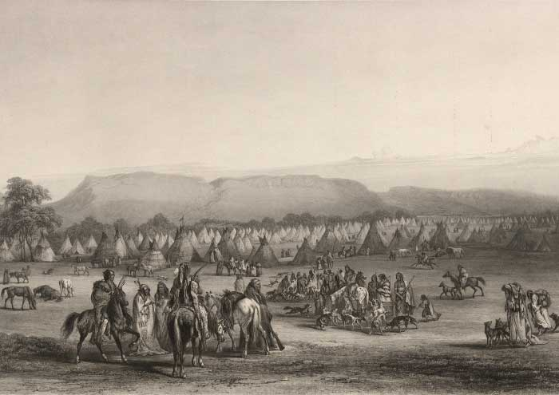  - Canadian food-foraging group Adapted well to their ecosystem
Media | 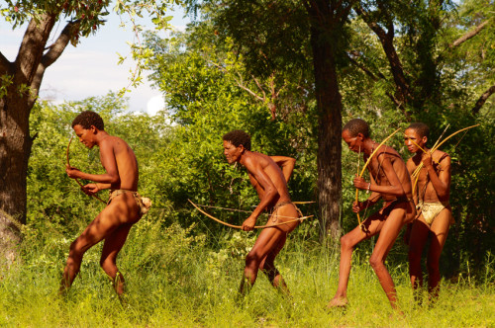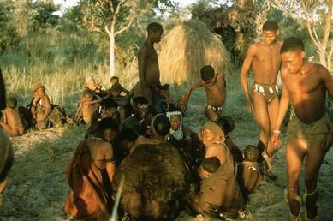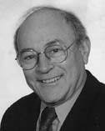
Richard B. Lee > | - He is known for his research on hunting and gathering, through participant observational  - He worked with the Ju/’hoansi San of the Kalahari Desert in Botswana, since 1963.  - Currently teaches at University of Toronto and has also studied foragers in Tanzania, Alaska, Australia, northern Russia, and some regions of Canadian subarctic.  - The remarkable peace of Lee’s “Eating Christmas in the Kalahari” has helped to enlighten most students to the benefits of fieldwork and participant observation.  - He is the co-founder along with Irven DeVore of the Kalahari research group.  - It is an group of scholars who conducted fieldwork among the San peoples | Annette B. Weiner  - She was an American anthropologist.  - She was known for her ethnographic works in the Trobiand Isands and her development of the concept of inalienable wealth in social anthropological theory.  - She studied the importance of Trobiand Women (mentioned in ch 2).
Media
Gender Differences > | - Opposite to what some researchers think, women play a large part in traditional foraging groups.  - Foraging groups exhibit a great deal of variability in their marriage practices  - Not all groups arrange marriage for their young people, and in those that do, women still exert control over practices such as mother-in-law relationships, divorce rights, and choosing their own partners  - When unsatisfied with a marriage, the women can chose to go back home which signals the end of the marriage.  - And in some groups men need to prove that they are good providers before the mothers will allow their daughter to get married.  - Hunter-gathers leave decision making regarding men’s work to the men, and women’s work to the women, allowing the experts in each area to make the decisions  - And for group decisions, both age and gender play a significant role | - Elders of both genders in the Evenki culture of eastern Eurasia coordinate activities within the community.  - For the Netsilik peoples in Inuit, the women are responsible for making warm winter clothing and boots because without this, the men would perish while hunting.
Media | 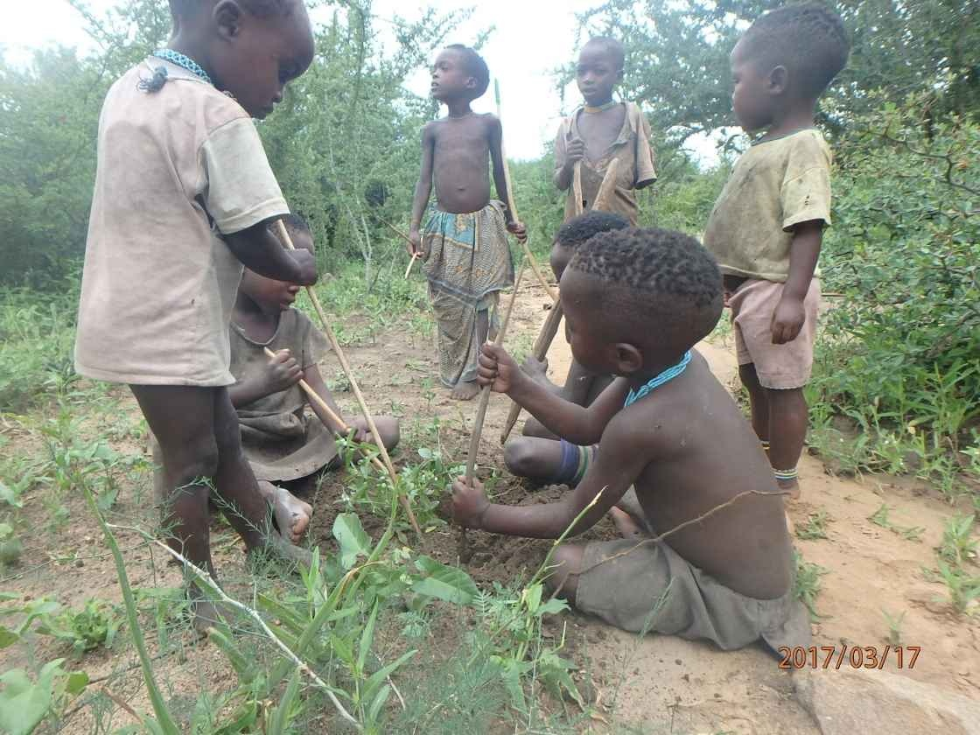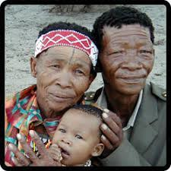
Mobility and T  echnology > | Food foragers: people who do not farm or practice or animal hunting  Food foragers must be willing to move within their home/ fixed territory to ensure continuous supply of food  Some groups have fixed annual routes in a restricted territory whereas others depend on animal herd movements to determine their seasonal movements  Some also depend on the availability of water  Hunting styles & the equipment available also play a role in determining pop. size & movement | - Mbuti people hunt with nets. (E)  - Requires 7 to 30 families, hence their camps are fairly large  - The Mbuti people who hunt with bows and arrows  - Smaller camps; 3 to 6 families  - Archers > travel great distance every day to keep out of each other's way  - Only during midsummer they collect into larger camps for religious ceremonies, wedding, and social gatherings.  - W/out nets they are less effective > when net hunters are widely dispersed & not competing for meat > they can come together and hunt.  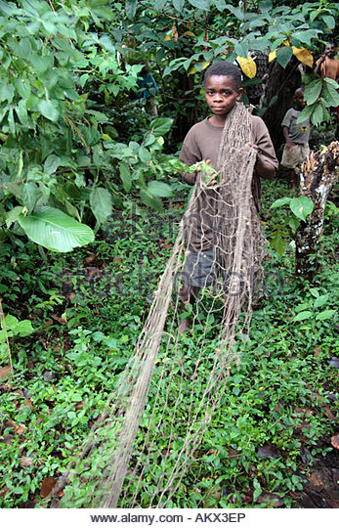 V.S. 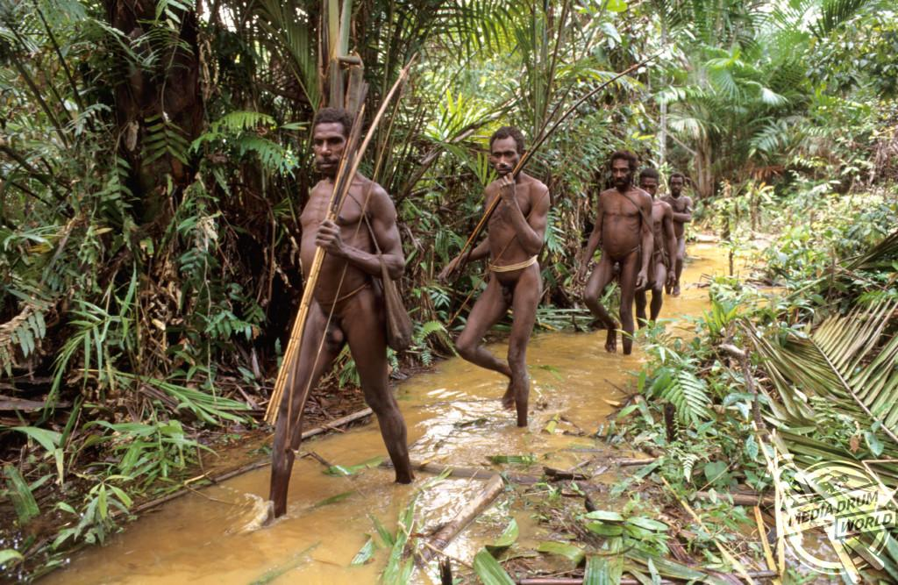
Media
Camp Organization | - Food foraging is an adaptation  - An important characteristic is that group sizes are small, usually less that 100 people  - Carrying Capacity: the number of people the available resources can support given the foraging techniques  - Involves the immediate presence of food and water  - Also involves the tools and work necessary to secure them  - Density of social relations: the number and intensity of interactions among camp members  - More people means higher social density  - Can mean more conflict  - Population size is also dependant on the gathering techniques of the community  - This variable is always in flux  - People may move in and out of communities as social relations change (ie if there are conflicts, families may move away to other communities) | - Blackfoot band membership was fluid  - People are encouraged to stay or leave the community depending on the burden for working adults
Media
Division of Labour > | - Division of labour is a crucial component of social organization and cooperation  - Women’s work consist of gathering and processing a variety of vegetal foods and other domestic chores  - Men may walk ten kilometers a day to gather food  - The sexes were reduced to minor proportions but labour division was maintained  - In general men can run faster than women  - Women work in food foraging while taking care of children  - Helps in community organization  - This is done because it supports community needs (not related to power and dominance) | Ex.  - The Korowai have division of labour: women gather and prepare food and men hunt  - pastoral groups such as the Kurds: women are responsible for tending the herds and carrying out chores like milking the ewes (female sheep)
Media | 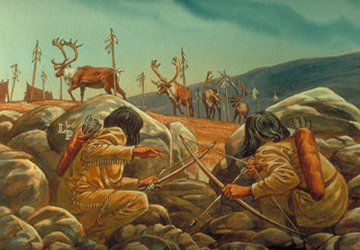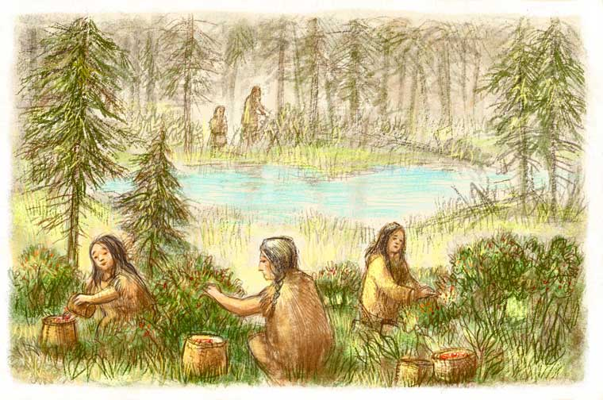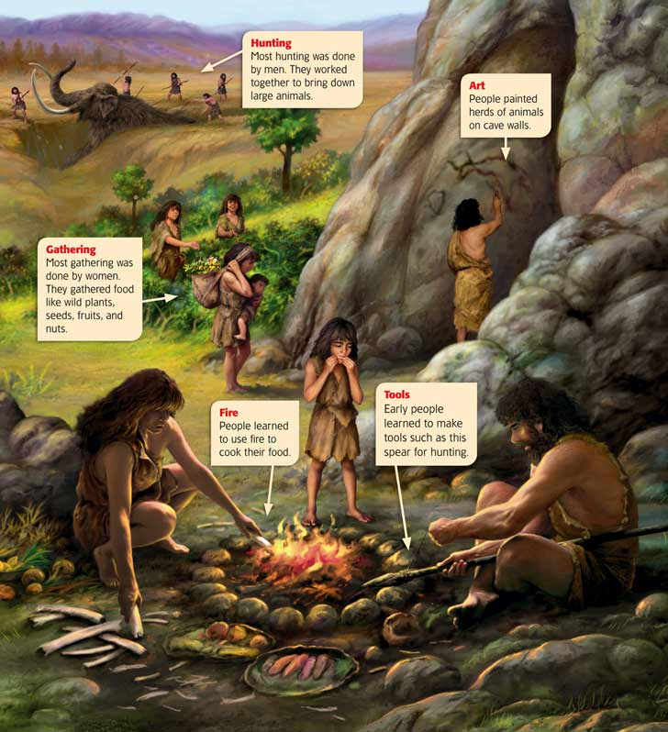
Food Sharing > | - sharing of food between adults (rare among non human primates)  - food Sharing occurs in camps, where people come together and spend time (public space)  - Food sharing is a way of storing it for the future  - Food sharing has the value of distribution resources needed for subsistence  General Reciprocity | examples:  Ju’hoansi: meat distribution  - not restricted for women, but restricted for men  -vegetables are shared liberally  -meat sharing maintains good relationships between people  Blackfoot:  - leader distributes meat and hides to people  Copper Inuits seal sharing:  - Certain parts of deal are associated with different rewards  - -structured sharing for ringed seals and non structured sharing for bearded seals  - Men visit hunters home and slice off the pieces that they want (knife wielding competition)
Media | 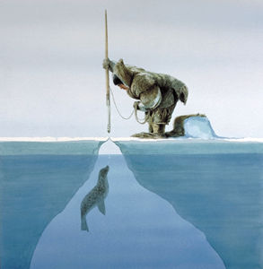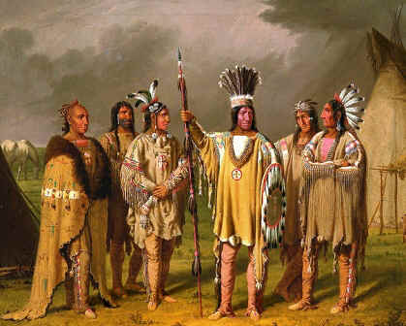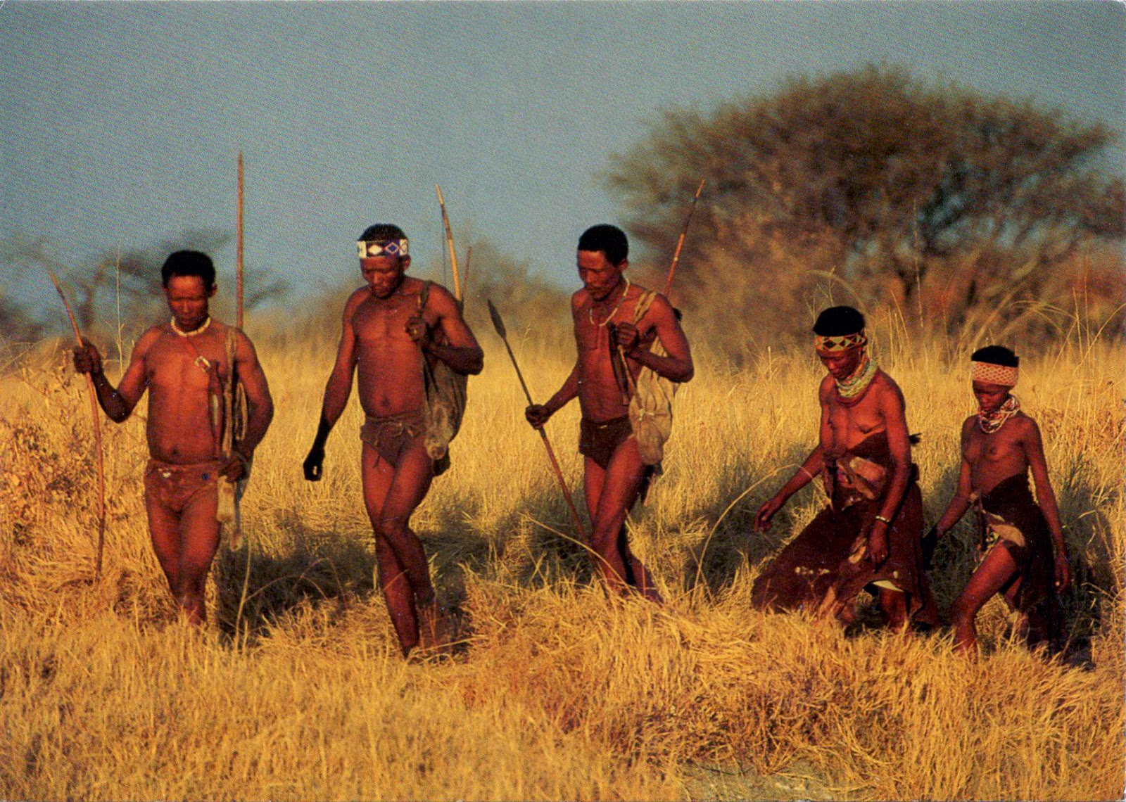
Egalitarian Society > | - People do not have many belongings due to high mobility  - Age and sex are only sources of significant status (But don’t even matter that much)  - Status does not mean that there is inequality  - Women and men both have rituals that exclude the other  - Women are in charge of their own work  - Food surplus is only for colder weather and food is distributed equally, no one receives high status through food hoarding  - Most groups use home ranges, resources open to all members  - Shares without expecting something in return; hoarding is considered morally wrong | - For the Montagnais and Naskapi (Innu) people of Labrador hunt was important in their society  - Women made clothing and other necessities but did not participate in food hunting as much as is common in food foraging societies  - Women were not a part of ritual feasts to do with hunting, men were excluded from women’s ritual feasts  - Each sex focused only on their own activities
Media | 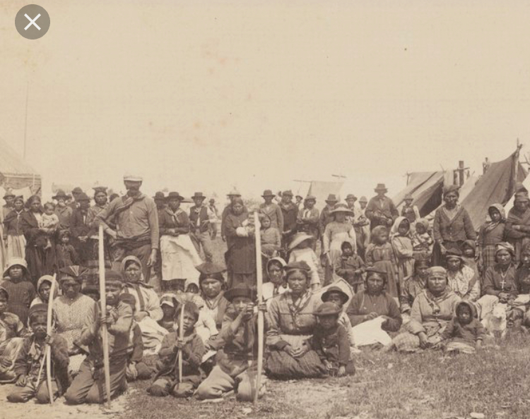

Monday November 6, 2017

The Original Affluent Society - Marshall Sahlins

Neolithic:

Paleolithic:

Eurocentric:

Imperialism:

What are Sahlins main thesis?
The hunter society is the original affluent society.

What are his main arguments?
-hunters have limited wants and sufficient means

What evidence does he deploy to support these arguments?
-hunters have plenty of leisure time
-they have few minimalistic possessions
-poverty is a relation between people

+

Why might it be controversial?
It criticizes people’s inaction oni the issue of world hunger.

Were hunter-gatherers affluent?
Hunter-gatherers were affluent in the sense that each member’s subsistence need were fulfilled because they lived communally and had an objectively low standard of living.

Why have many individuals assumed that foragers were not affluent?
-Individuals may have assumed that foragers were not affleurer because of the misconception that they spend most of their time chasing and hunting (seen as an
inefficient strategy)

How do we define affluence?
- WEALTH, material possessions, Capital (financial means)
- material wants being easily satisfied

How do food foragers define affluence?
- Accessibility to plant food resources
- Accessibility to hunting/animal food sources

How should we define affluence?
Affluence is the fulfillment of each member’s subsistence needs in a society. (Not all societies are based on material wants)

Video Worksheet: Patterns of Subsistence - Hunter Gatherers and Pastoralists
https://www.youtube.com/watch?v=KlVrrNlmJyg

- Explain the sexual division of labour amongst the hunter gatherer !Kung society of the Kalahari Desert
Women are gatherers, whereas men are hunters.

- In what way do the Mbuti pygmies of Zaire’s rainforests exemplify a similar pattern of subsistence? http://ngm.nationalgeographic.com/ngm/0509/feature5/multimedia/htm

- What is the meaning of the name of the “Netsilik” Inuit band? http://www.canadianencyclopedia.com/index.cfn?PgNm=TCE&Params=A1ARTA0005689
The place where the seal lives.

- In what ways is the seal hunt a cooperative venture?
The men disperse on the ice to find different seal holes, in order to maximize the society’s chance of finding and acquiring a seal.

- What form of social organization is typical of hunter gatherer societies such as the Netsilik?
They are an egalitarian society.

- What values are expressed in this type of organization?
Members have equal rights and opportunities.

- What is the legacy bequeathed to us from hunter gatherers?
The idea of egalitarianism.

- The Nuer tribe of the Sudan are pastoralists. Explain their subsistence economy and the dependence on cattle.
Relatively large cattle population allows for a larger society.

- Describe the rite of passage for a Nuer boy.
Puberty: 6 cuts across the forehead
Marriage: Exchange cattle for a woman’s courtship

- What is the difference between a TRIBE and a BAND? (see textbook)
Tribe: a collection of bands
Band: A kin based society, small in population

- Contrast the Bessari’s form of pastoralism with that of the Nuer.
Bessari herded sheep and the Nuer herded cattle.

- Ho is decent determined in Bessari society? http://www.questia.com/PM.qst?a=o&d=1534594
It’s patrillinio (decided through the father's family line)

- In what sense is the American cowboy considered to be an example of pastorialism?
Urban farmers

- Do you like the mystique of the foraging society? Would YOU want to “go back to the land”?
Nah b.

Urban Foraging

1. Would you ever forage for food in an urban environment, why or why not?
2. What are some obstacles to Urban Food foraging today? Would it be a viable way to sustain ourselves as a culture?
3. Have you ever considered that there is a world of edible food outside your door? Why or why not?
4. How does modern capitalism oppose an Urban Foraging lifestyle?

Questions for Critical Thought: Textbook p 149

- Is change always adaptive? What are some examples of non-adaptive thought within North American culture?
- The Incas of South America did not have or widely use the wheel or the concept of zero. Does this mean Incan culture might have been non-adaptive?
- Is cultural change or increasing technical complexity the same as progress? Why or why not? Do you believe in human “progress”? If so, in what sense do we progress?
- Can large-scale, technologically advanced societies and small scale societies coexist? Under what circumstances could they co-exist?
- If Global Warming causes dramatic climate changes, how might we adapt? For example, if the temperatures increase and the moisture levels decrease, what adaptations will agriculturalists have to make? Will we be able to adapt?
- If the Canadian family farm disappears, how will this affect the economic and social life of all Canadians?
- In North America, our reliance (some would say over reliance) on technology makes us vulnerable if this technology fails us. As a case in point, the August 2003 blackout in eastern North America affected 50 million people. Have we become too reliant on advanced technology? What happens if this technology fails us (i.e. what would happen if we no longer had access to gasoline for our vehicles? Are there ways for us to avoid or reduce the impact of technology failures?

